  lAB6  Combinational Logic  Name : 黃翊宏 Student ID : 01357101 |  | Note  - All files must be converted to PDF format before submission.  Submission deadline: Next Tuesday at 1:00 PM  Each person submits one assignment.

※Please use Win + Shift + S for screenshots. Do not take photos of the screen.

- Lab6-1：

Main Code Screenshot
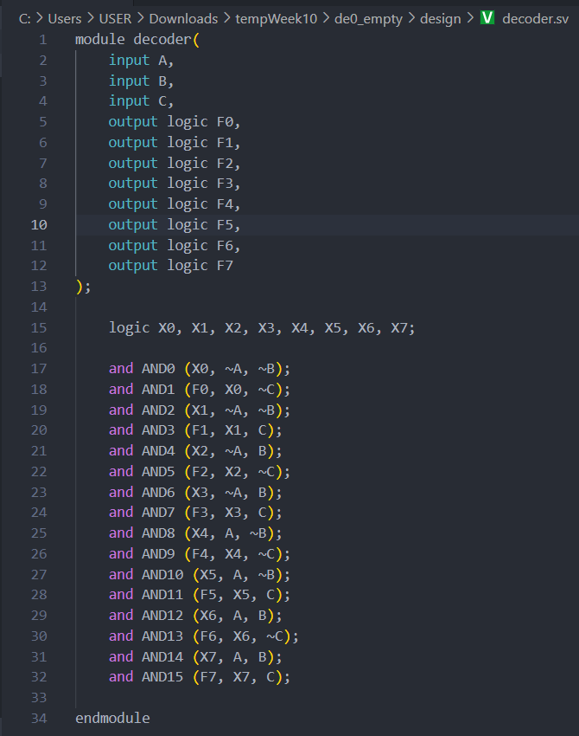
Testbench Screenshot
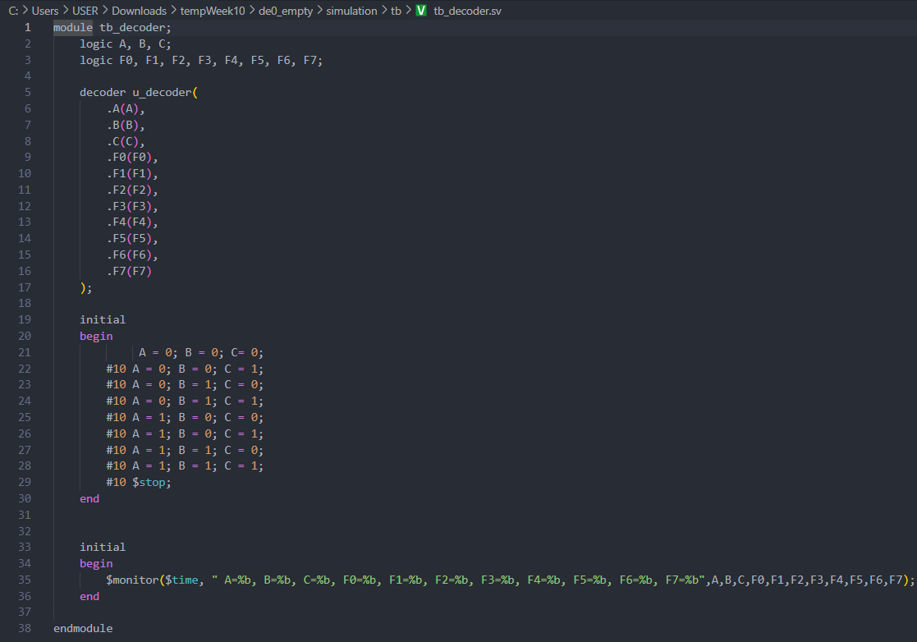
Waveform and Result Screenshot
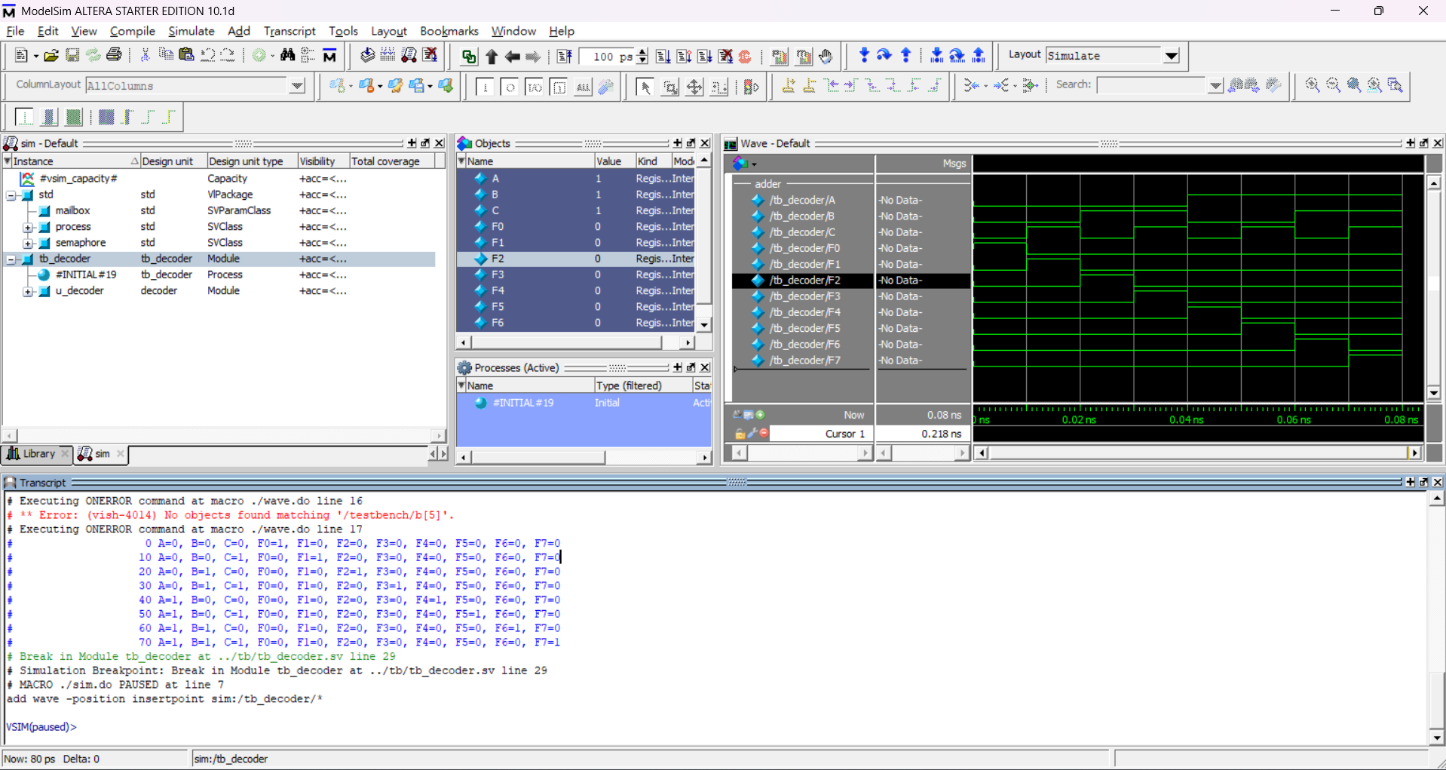

- Lab6-2：

Main Code Screenshot
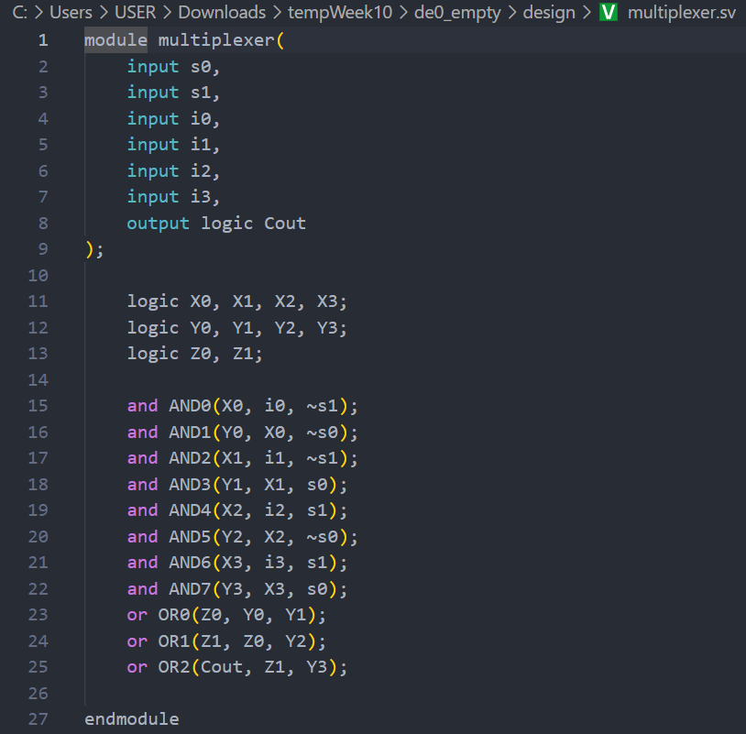
Testbench Screenshot
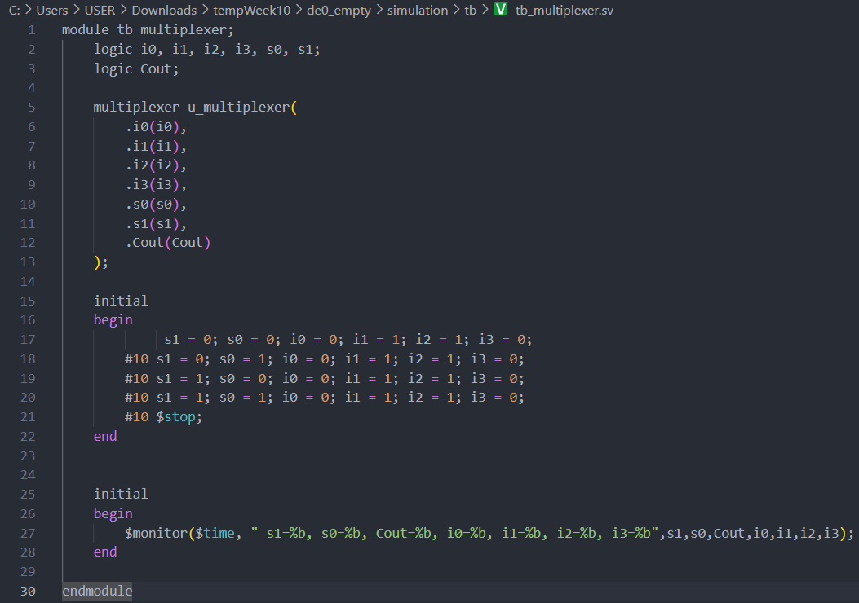
Waveform and Result Screenshot
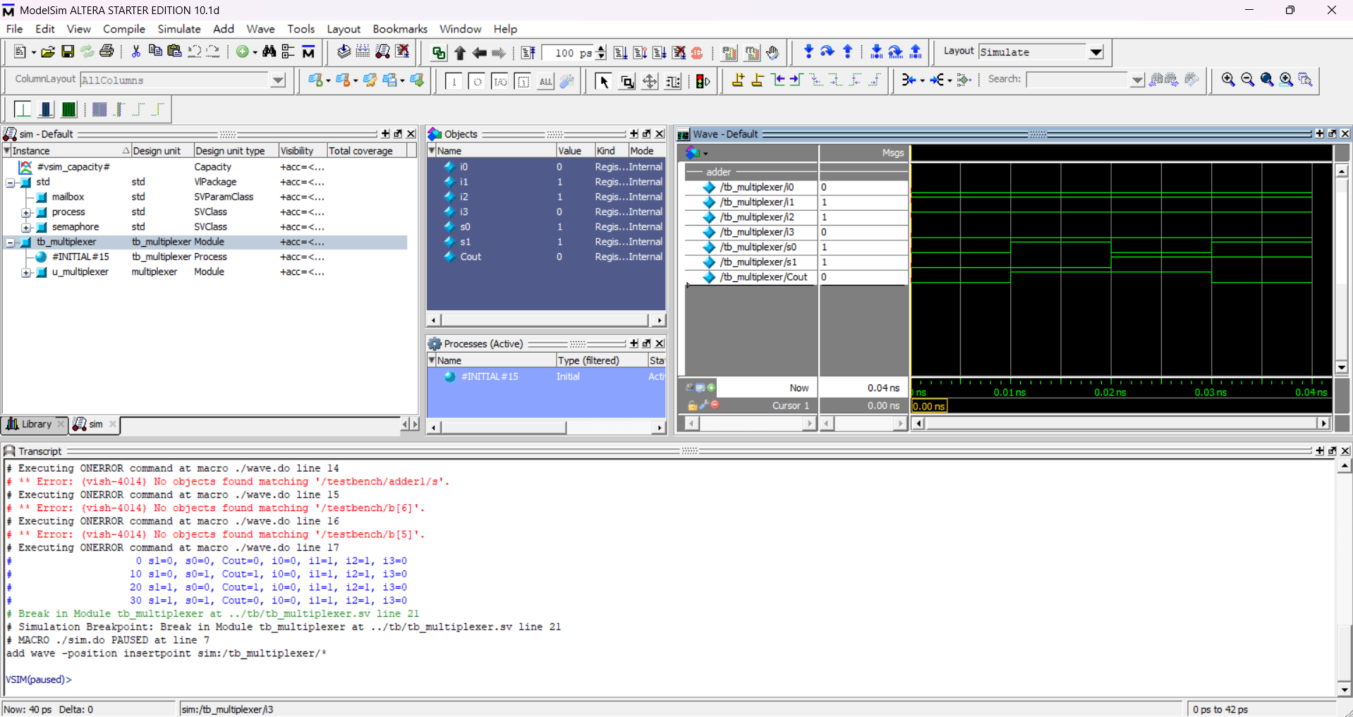

- Lab6-3：

Main Code Screenshot
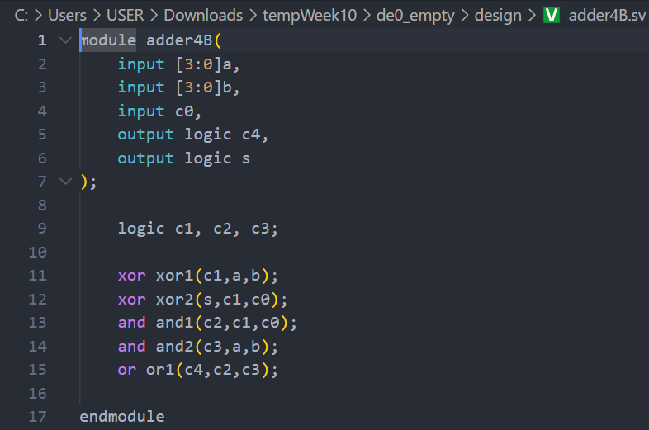
Testbench Screenshot
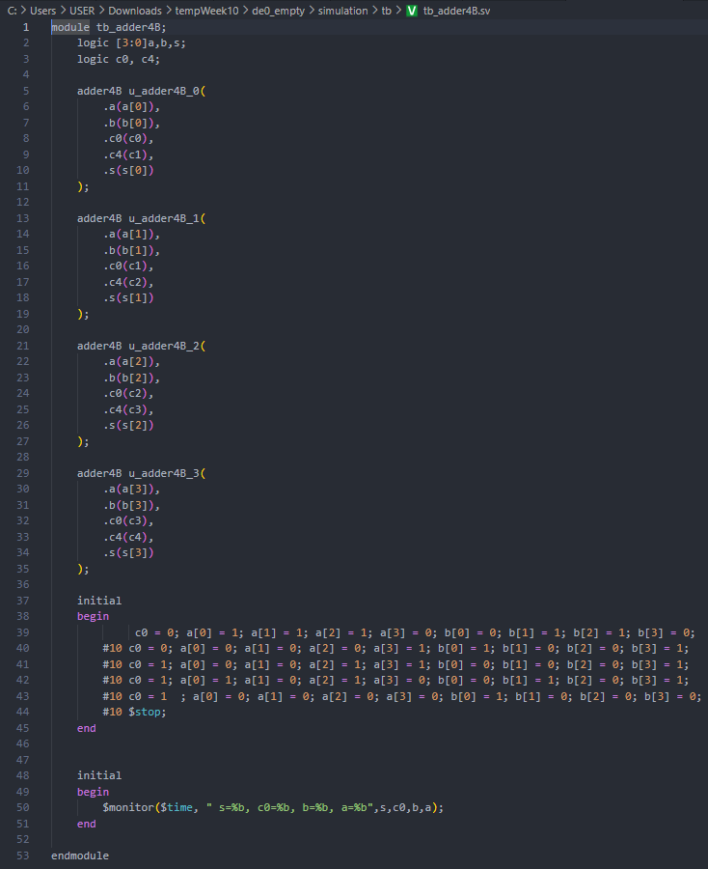
Waveform and Result Screenshot
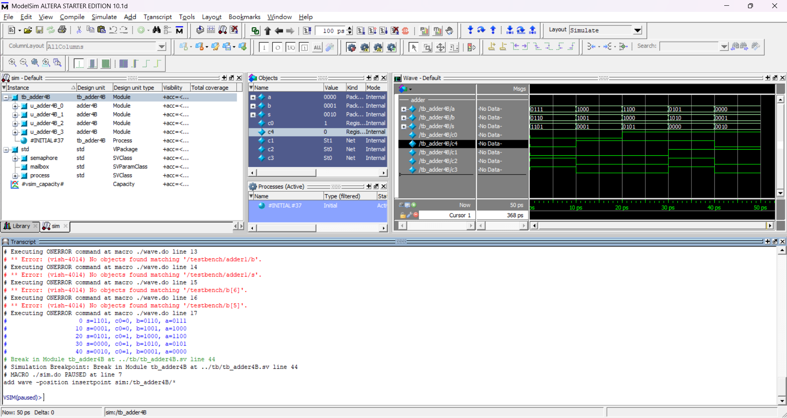

- Lab Summary and Reflection:
Summary
In this week’s digital logic laboratory, we employed Quartus to author and synthesize a series of combinational circuits using System Verilog. We began by defining each module—namely a 3-to-8 decoder, a 4-to-1 multiplexer, and a 4-bit ripple-carry adder—specifying clear input/output ports and leveraging the logic data type for internal signals citeturn0file1turn0file2. For each design, we wrote gate-level descriptions that mirrored the textbook symbols, then constructed comprehensive test benches to exhaustively exercise all possible input combinations. Through ModelSim simulation driven by .do scripts, we generated waveforms to verify that the decoder correctly asserted one of eight outputs based on three inputs, the multiplexer faithfully routed the selected data line to its output, and the adder produced accurate sum and carry bits across four-bit operands citeturn0file2.
Reflection
Working on these System Verilog implementations deepened my appreciation for HDL design flow and reinforced best practices in module naming, signal declaration, and operator precedence—insights underscored by the variety of System Verilog operators covered during the exercise citeturn0file3. Debugging mismatches between expected and simulated results taught me to pay close attention to sensitivity lists in always blocks and to verify bit widths at every stage. Moreover, integrating Quartus for synthesis and ModelSim for simulation bolstered my confidence in FPGA toolchains and prepared me to tackle more complex sequential systems. Moving forward, I plan to extend these skills toward a 4-bit adder/subtractor with overflow detection and to explore resource optimization techniques for improved logic utilization.

